THE UNITED REPUBLIC OF TANZANIA <<insert institution logo>>

<<Insert your Institution’s Name >>

Document Title
<<NAME OF THE SYSTEM>>
SYSTEM DESIGN DOCUMENT
APPROVAL | Name | Job Title/ Role | Signature | Date
Approved By | <<Name of Approver>> | <<Title>> | <<Signature>> | <<Date>>

Table of Contents
ACRONYMS 3
1. INTRODUCTION 4
1.1. Overview 4
1.2. Purpose 4
1.3. Rationale 4
1.4. Scope 4
1.5. Intended Audience 5
2. REFERENCED DOCUMENTS AND DEFINITIONS 5
2.1. Referenced Documents 5
3. SYSTEM OVERVIEW AND CONTEXT 5
3.1. System Objectives 5
3.2. System Context 6
3.3. System Functions 7
3.4. System Design Constraints 7
3.5. System Design Drivers 8
4. DESIGN CONSIDERATIONS 8
4.1. Assumptions and Dependencies 8
4.1.1. Assumptions 8
4.1.2. Dependencies 8
5. SYSTEM ARCHITECTURE DESIGN 9
5.1. High Level Architecture 9
5.2. Logical Architecture 10
5.3. Deployment Architecture 10
6. DETAILED SYSTEM DESIGN 11
6.1. Component Design 11
6.2. Data Design 12
6.2.1. Data Design Artifacts 12
6.3. User Interface (UI) Design 14
6.3.1. Key UI Design Elements 14
6.4. Workflow Diagrams 14
7. SECURITY AND PRIVACY DESIGN 17
8. SYSTEM INTERGRATION DESIGN 19
9. PERFORMANCE AND RELIABILITY DESIGN 19
10. DEPLOYMENT DESIGN 20
11. MAINTENANCE AND SUPPORT 20
12. IMPLEMENTATION, ENFORCEMENT AND REVIEW 21
13. DOCUMENT CONTROL 21

ACRONYMS
CI/CD | Continuous Integration Continuous Deployment
EFD | Entity Relationship Diagrams
e-GA | e-Government Authority
ICT | Information & Communication Technology
SDD | System design diagram
SRS | System Requirements Specification
UAT | User Acceptance Testing

INTRODUCTION

Overview
<<Insert name of the public institution>>is a government institution with the
functions of << Provide a concise overview of the institution’s history and legal standing>>.

<<Provide a brief general overview of the system, describing its goals and main functions >>.

Purpose
This document defines the design for <<Insert system name>>. It describes the technical solution and design considerations developed to meet the requirements outlined in the System Requirements Specification (SRS), relevant regulations, system concept note, and project approval guidelines. It also outlines the main components that support the system’s functions. This document may be updated as necessary to reflect any changes made during development until the system is deployed to production.

Rationale
This document provides a structured description of the System, outlining its design, architecture, and operational considerations. Key reasons for creating the SDD include:
- Guiding System Development;
- Ensuring Consistency and Alignment;
- Facilitating Communication Among Stakeholders; and
- Documenting Design Decisions.

Scope
This document describes the design objectives, design considerations, system and its sub-systems design architecture including << e.g. process flow diagrams, behavior diagrams (use cases), data design (Entity Relationship Diagrams (EFD), data dictionary and external interface designs >>
It also describes how the system/application will be constructed by specifying the components to be used, how they will be organized in relation to each other, and the general principles of the system's internal construction.

Intended Audience
The intended audiences for this document are<< Management (decision makers), Technical Teams, Business Analysts, System Developers, Database Administrators, System Security Officers, System Testers and System Quality Assurance practitioner>>.

REFERENCED DOCUMENTS AND DEFINITIONS
This section identifies key documents, standards, and reference materials that support the design, development, and implementation of the <<system name>>. These documents provide context, justification, regulatory requirements, and design inputs necessary for preparing and validating this Software Design Document (SDD).

Referenced Documents
The following documents shall be used as primary references:
<<Include all reference documents and their definitions e.g >>
- Business Case or Concept Note;
- System Requirements Specification (SRS);
- ICT Project Management Procedures;
- Business Requirements Document (BRD);
- Existing System Documentation (e.g., System Review Reports);
- Standards and Guidelines for Development, Acquisition, Operation and Maintenance of e-Government Applications; and
- Enterprise Architecture etc

SYSTEM OVERVIEW AND CONTEXT

System Objectives
The analysis of challenges identified together with business requirements specification, resulted into the following system objectives:

<<State how the system supports institutional strategic objectives>>

S.N | Objective | Capabilities
1.
2.
3.

System Context
This provides a high-level view of the <<name of system>> System and illustrates how it interacts with entities such as users, departments, systems, and databases. By defining the boundaries of the system and identifies all inputs, outputs, and data exchanges between the system and its external environment.

<<Include a high-level diagram >>

<< -- Recommended Diagram Types

Diagram Type | Description
System Context Diagram | shows interactions with users and external systems.
High-Level Architecture Diagram | illustrates overall system components and flow.

-- >>

<< Example of A Context Diagram >>

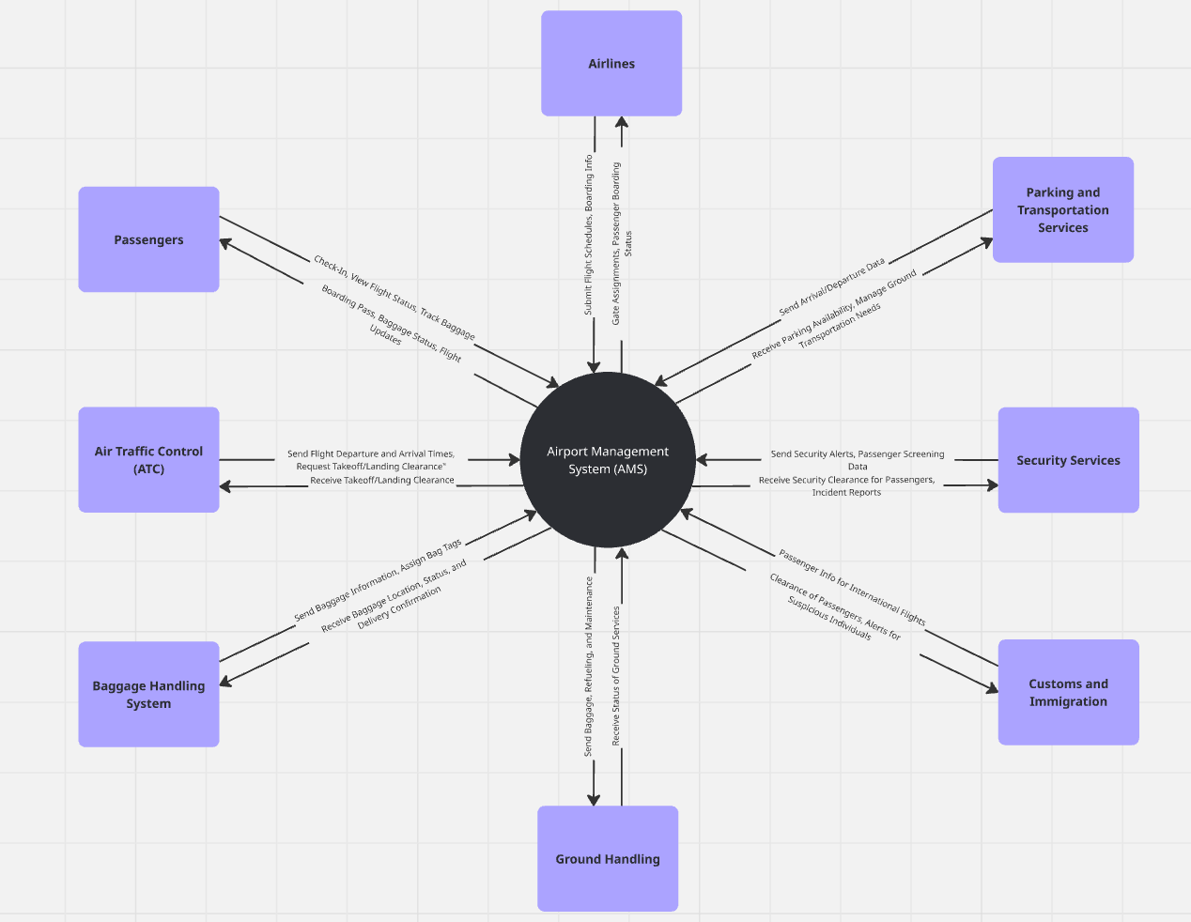

System Functions
The <<name of system>> System is designed to deliver a range of core and supporting functions that enable the institution to achieve its operational and strategic objectives.

The major system functions include:
<<include major system functions>>

System Design Constraints
The design and implementation of the <<name of system>> System are subject to several constraints that influence architectural, technical, and operational decisions. These constraints define the boundaries within which the system must operate and ensure that the design remains realistic and achievable.
<<Constraints should be included or minimized according to the system's specifications e.g integration dependencies, operational Environment >>

System Design Drivers
The design of the <<name of system>> System is guided by the following drivers.
Driver | Description | Source / Reference | Impact on Design | Trade-offs / Constraints
Performance | The system must handle high transaction volumes during peak hours (e.g., holiday ticket sales). | Functional Requirement FR<<>> | Implemented load balancing and caching mechanisms using <<>>. | Increased infrastructure cost due to use of multiple servers.
Security and Privacy | Sensitive customer and payment data must be protected. | e-GA Security Guidelines, ISO/IEC 27001 | Implemented HTTPS, database encryption, MFA, and audit logging. | Slight increase in authentication time for end users.
Usability | The platform must be simple and accessible in both English and Swahili. | User Requirement UR<<>> | Adopted a responsive front-end design using Angular with bilingual support. | Increased UI/UX design time.
Scalability | The system must support growth in user base and new train routes. | System Requirement SR-<<>> | Chosen microservices architecture with containerized deployment. | Added complexity in deployment management.
<< ------ >> | << ------ >> | << ------ >> | << ------ >> | << ------ >>

DESIGN CONSIDERATIONS
In developing the <<name of system>> System, a range of design considerations have been assessed to ensure the solution is both practical and sustainable.

Assumptions and Dependencies

Assumptions
The design of the <<name of system>> System is based on the following key assumptions:

<<include specific assumption>>

Dependencies
The <<name of system>> System relies on several external and internal dependencies that must be in place for the system to operate effectively which include:
<<external systems, ICT support and maintenance, institutional policies>>

SYSTEM ARCHITECTURE DESIGN
The system architecture design of <<Name of the System>> identifies the major subsystems, external interfaces, and communication channels between the various components, providing a clear and comprehensive understanding of how the system operates as an integrated whole.

High Level Architecture

<< include High Level Architecture Diagram that portrays system components and interactions>>

<< Examples System Architecture Diagrams>>
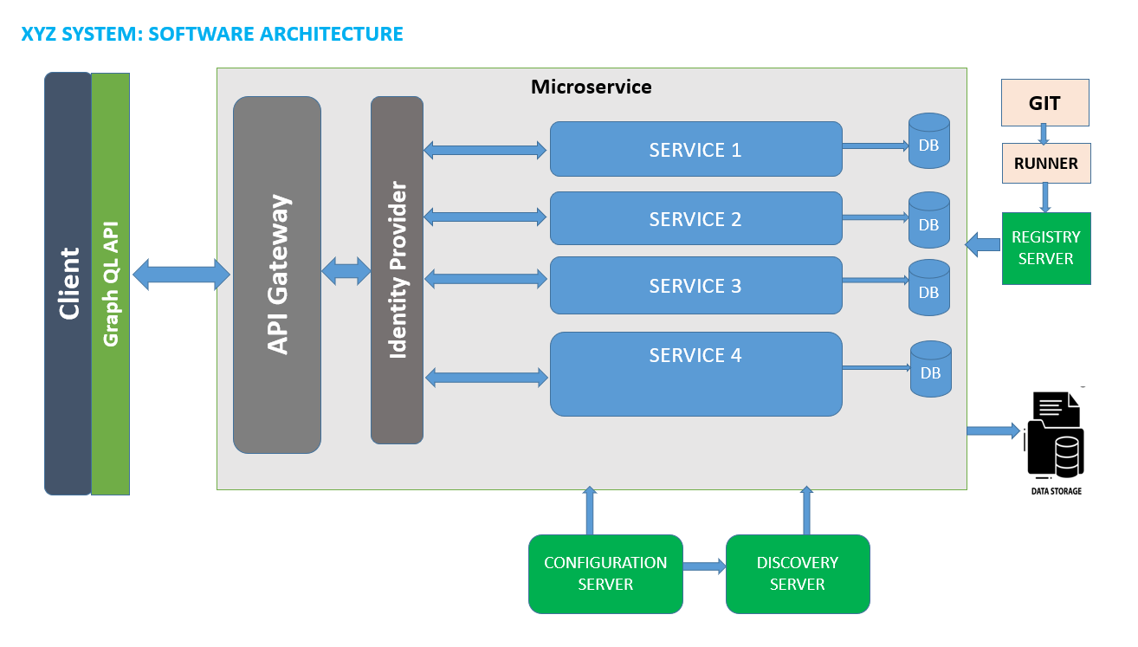

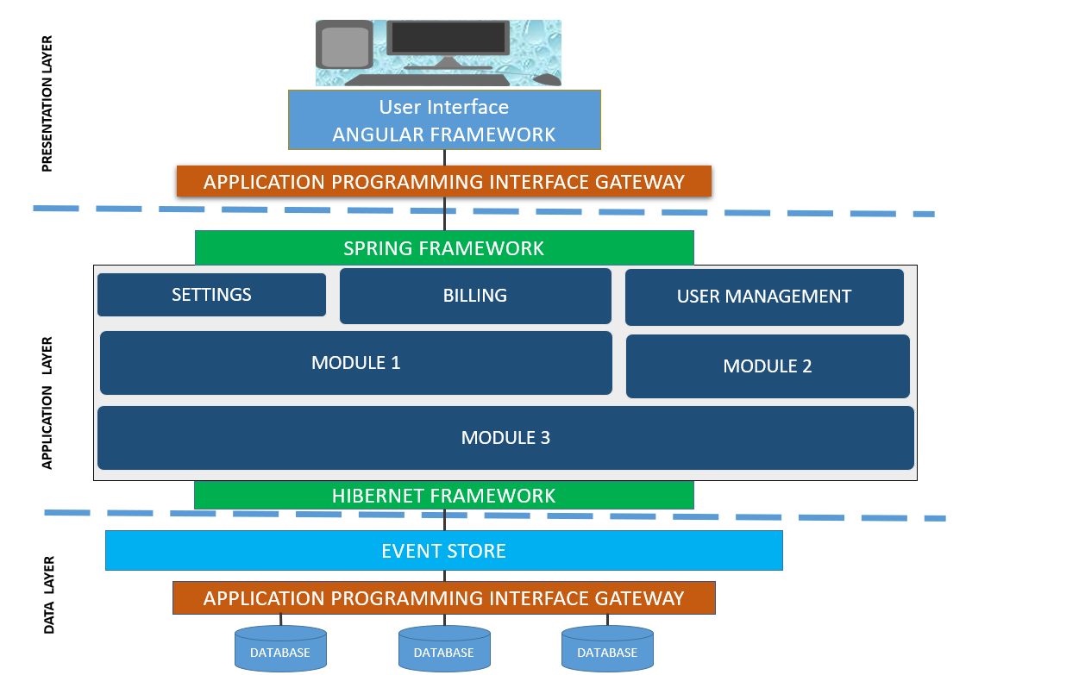

Logical Architecture
The Logical Architecture of <<Name of the System>> focuses on the functionality and interactions among the major software modules, without considering hardware configurations or deployment details.
<< include logical architecture diagram>>

Deployment Architecture
The Deployment Diagram of <<Name of the System>> maps the logical components (as defined in the UML Component Diagram) onto the physical infrastructure nodes.
<< include deployment architecture diagram>>

<< -- Recommended Diagram Types
Diagram Types | Description
Logical Architecture Diagram | Shows main system modules and their relationships.
Physical Architecture Diagram | Details deployment and infrastructure topology.
Component Diagram (UML) | Depicts interactions between components.
Network Diagram | Illustrates network layout and communication flow.
Deployment Diagram | Maps software onto hardware or cloud infrastructure.
-- >>

DETAILED SYSTEM DESIGN
The Detailed Design provides an in-depth description of how each component, module, and subsystem of the system will be implemented. It translates the high-level architectural design into a technical blueprint that guides developers during system construction.
The Detailed Design of <<Name of the System>> defines:
<< ------------------------------------------------------------------------------------------
- The internal structure and behavior of each subsystem and component
- The data flow between components and modules
- Algorithms, interfaces, and data structures used in implementation
- Error handling, logging, and exception management mechanisms
- Dependencies between components and third-party services
- Configuration parameters and environment-specific settings
----------------------------------------------------------------------------------- >>

Component Design
The Component Design of <<System Name>> translates the high-level architectural view into a detailed blueprint specifying how each system component will be structured, implemented, integrated, and tested to ensure the system functions as intended.
<<include component design diagram that articulate how the different parts of a system such as modules, classes or subsystems are structured and interconnected>>

Data Design
The Data Design of <<System Name>> ensures that all functional and non-functional data requirements are supported through a consistent, efficient, and secure data architecture.
This section defines how data is stored, how data is structured, how it flows, how it is protected, accessed and maintained through the system life cycle.
<<include data design Diagram >>>

<<-- Recommended Diagrams

Diagram Types | Description
Entity-Relationship Diagram (ERD) | Defines entities and database relationships
Data Dictionary Table | Documents data attributes and formats.
Data Flow Diagram (DFD) | shows logical flow of information within the system

-- >>

Data Design Artifacts
Data design artifacts include:
- Entity-Relationship Diagram (ERD)
- Data Dictionary
- Data Flow Diagram (DFD)
- Database Schema Diagram
- Data Security Classification
<<include data design artifacts>>>

<< Example of Entity Relationship Diagram (ERD) >>
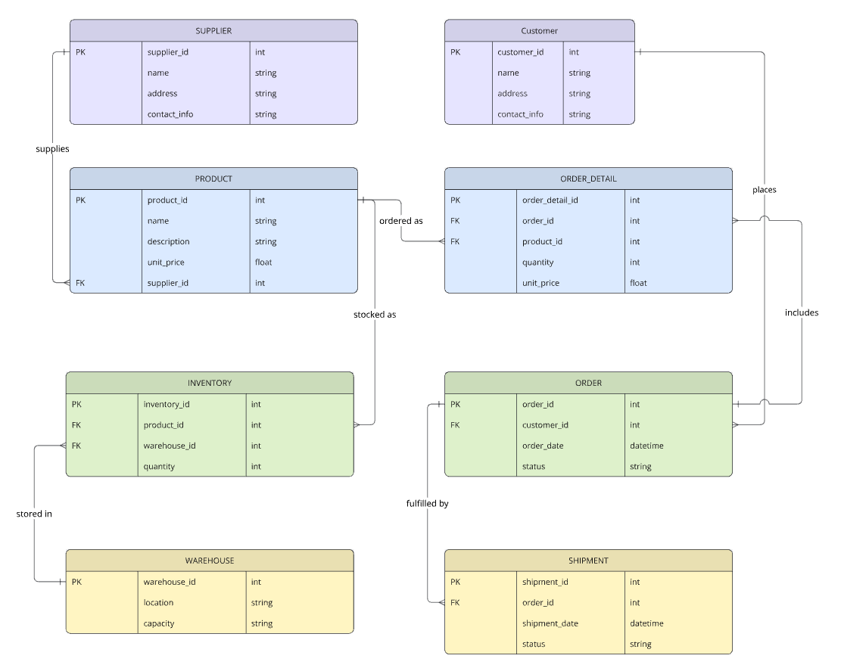
<< Example of Data Flow Diagram >>
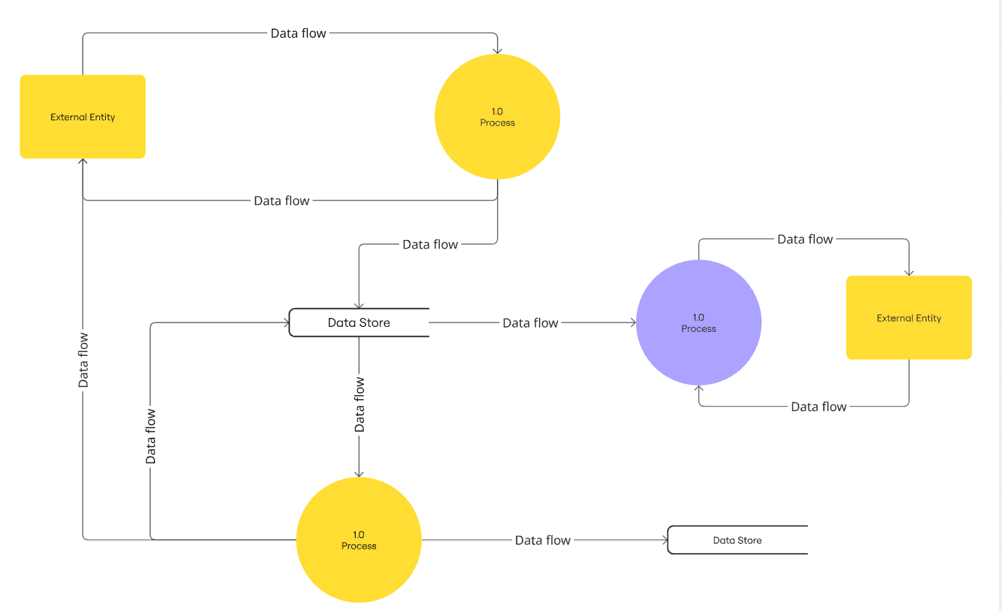

User Interface (UI) Design
The User Interface Design of <<System Name>> defines how users view, input, and receive information, ensuring a seamless and user-friendly experience. UI Design explains what users see and how they interact with the system.

The User Interface (UI) Design shall adhere to the following core principles:
- Consistency: Maintain uniform layout, colors, fonts, icons and interaction patterns across the system;
- Responsiveness: Ensure the UI works seamlessly across different devices, screen sizes and orientations;
- Simplicity: Design should be clear and simple to understand and help users focus on core tasks;
- Flexibility: Should be flexible enough to accommodate different user types, skill levels and context;
- Efficiency: Should allow users to complete tasks efficiently by minimizing the number of steps and providing shortcuts;
- Accessibility: Ensure the system is accessible to all user group including people with disabilities.
- << Add any other UI design principle >>

Key UI Design Elements
- Screen Layouts / Wireframes
- Navigation Structure
- UI Elements Catalog
- Style Guide
- Input / Output Design.
- Error Handling and Messages
- Accessibility Design

Workflow Diagrams
The Workflow Diagram of <<System Name>> illustrates who performs each activity, the order of operations, and how information flows between users, system components, and external entities.
<< Include workflow diagram such as sequence diagram, Activity Diagram, Data Flow Diagram (DFD)>>
<< Example of Sequence Diagram >>
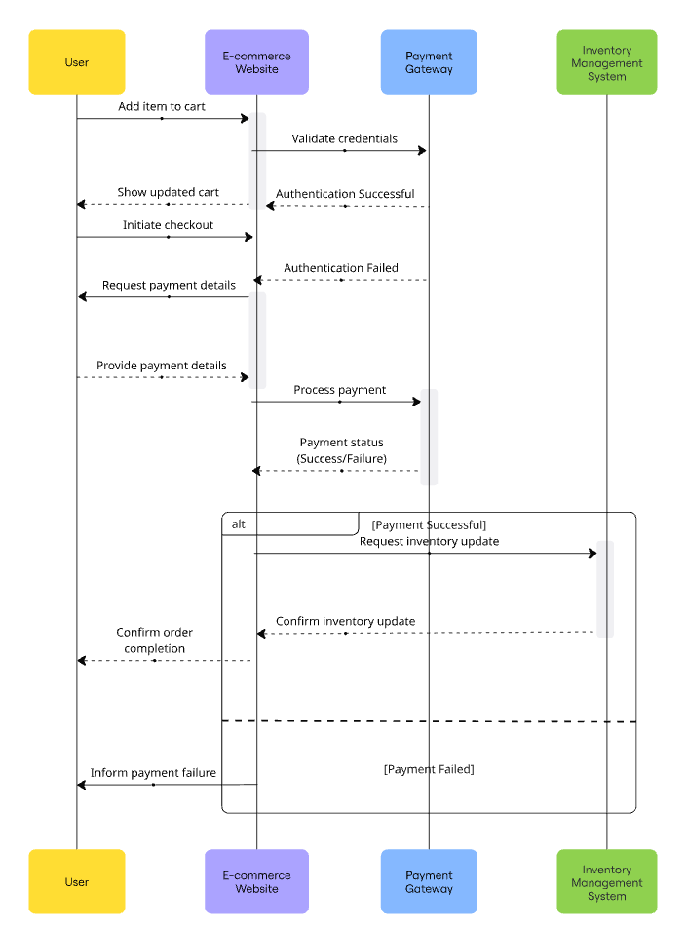

<< Example of Use Case Diagram >>

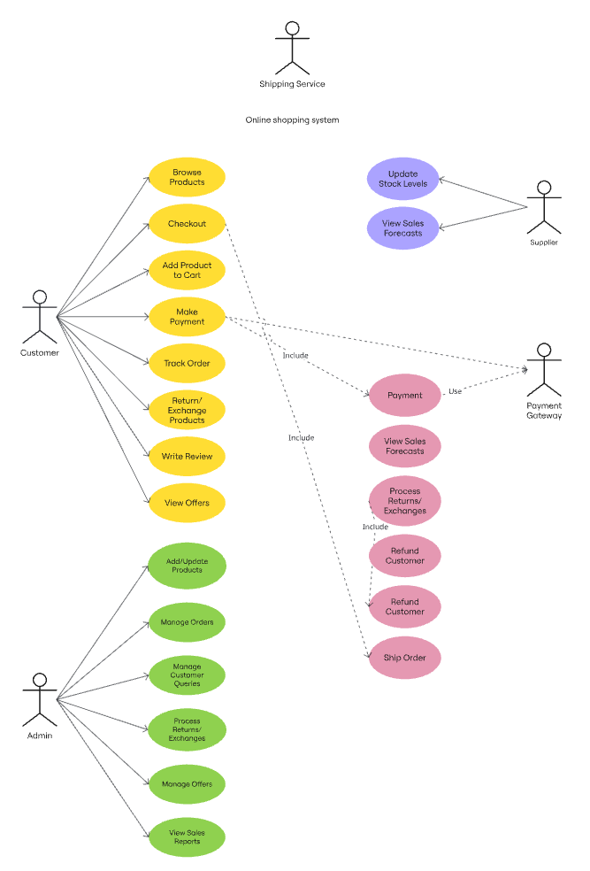
<< Example of Class Diagram >>
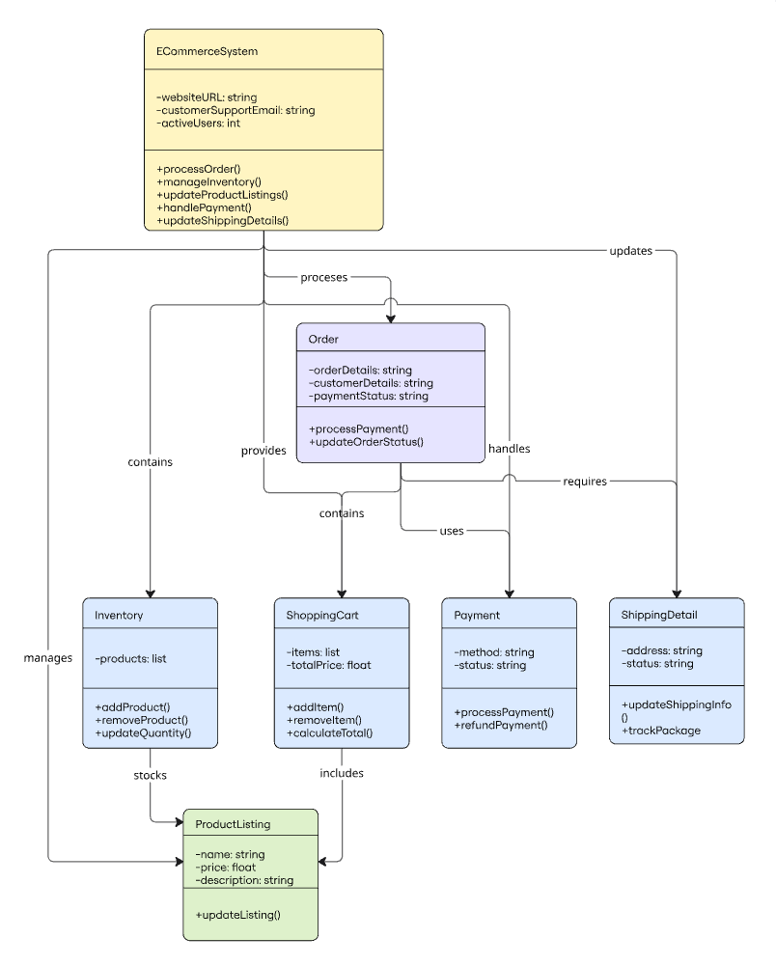

SECURITY AND PRIVACY DESIGN
<<System name>> specifies how information security principles (Confidentiality, Integrity and Availability) and privacy-by-design principles are integrated into every layer of the system from the user interface to the database and network.
<<Include security architecture diagram >>
<< -- Recommended Diagram Types
Diagram Type | Description
Security Architecture Diagram | Illustrates layers of protection and access controls
Access Control Matrix | Shows user roles and permissions in tabular form
Threat Model Diagram | Identifies system threats and mitigation measures.
-- >>
<<Example of Security Architecture Diagram>>
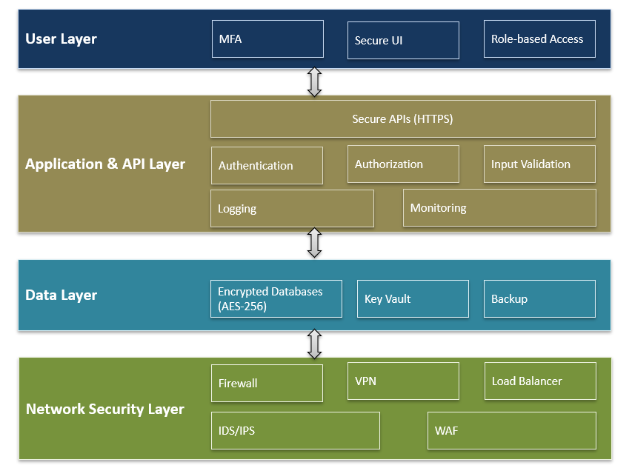

<< Example of a Security Threat Model Diagram >>
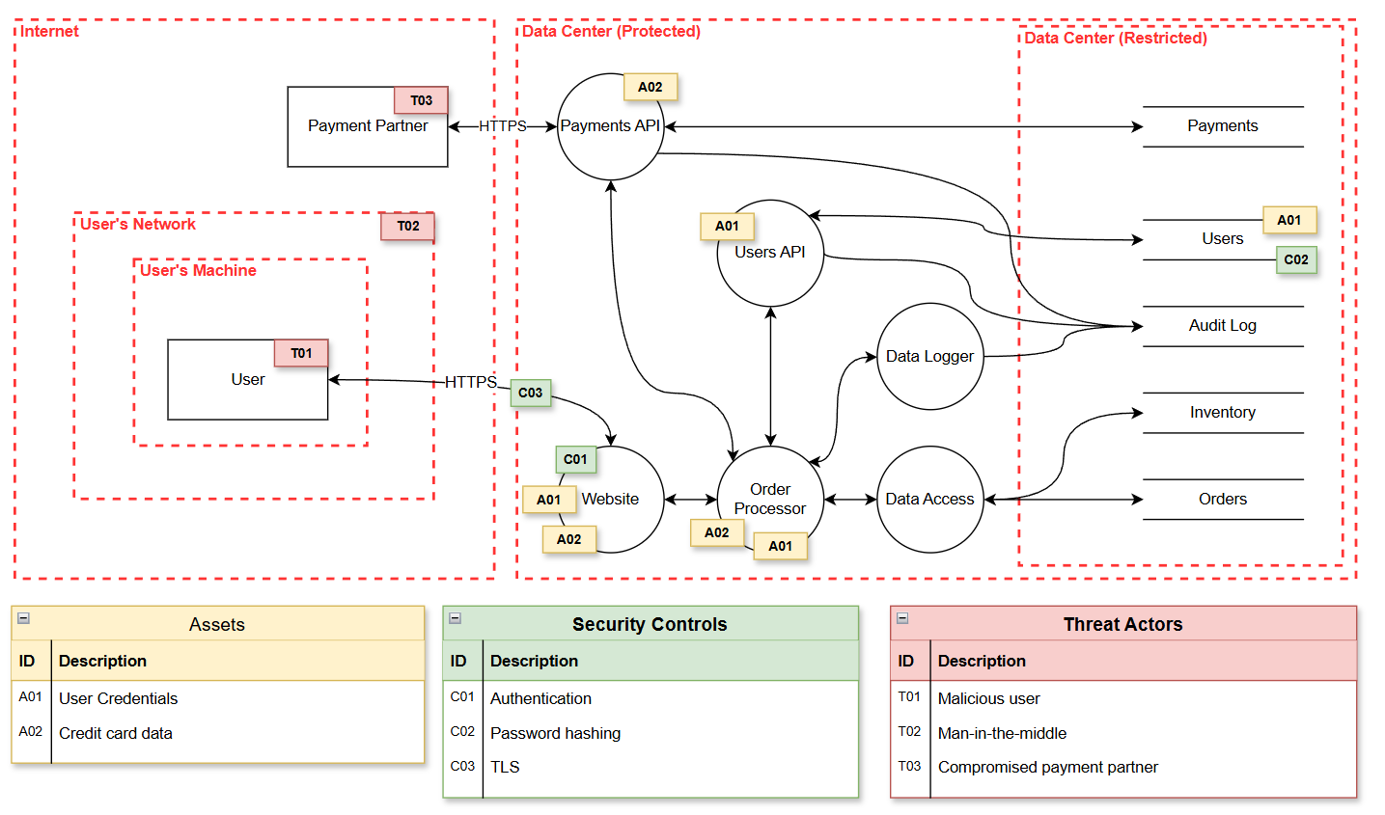

SYSTEM INTERGRATION DESIGN

This defines how << name of the system>> system interacts with external systems. Include API specifications, data exchange formats, and error handling mechanisms.
Example: 'Integration with GePG via REST API using HMAC SHA-256 signature validation.

<<Include System Architecture Design Diagram >>

<< -- Recommended Diagram Types
Diagram Type | Description
Integration Architecture Diagram | shows external systems and data exchange flow
Sequence Diagram | Details API call sequence between systems
Message Flow Diagram | Visualizes message formats and transport protocols
API Interaction Diagram | Outlines key endpoints and request-response structure
-- >>

PERFORMANCE AND RELIABILITY DESIGN
This defines the non-functional requirements that ensure << name of the system>> System operates efficiently under varying workloads and remains continuously available to users.

<< Include Performance and Reliability Design >>

<< -- Recommended Diagram Types
Diagram Type | Description
Load Balancing Diagram | Demonstrates traffic distribution mechanisms
Failover/Redundancy Diagram | Shows system continuity and disaster recovery setup
Caching Architecture Diagram | Explains caching layers and data access optimization
-- >>

DEPLOYMENT DESIGN
<< name of the system>> System will be deployed, configured, and maintained across the Development, Testing, UAT, and Production environments using <<e.g. CI/CID pipeline >> and a structured process that ensures consistency, scalability, and minimal downtime during updates.

<< Include Deployment Architecture, Environments, Deployment Workflow and Hardware Specifications >>

<< -- Recommended Diagram Types
Diagram Type | Description
Deployment Diagram (UML) | Maps software components to environments
Environment Topology Diagram | Outlines development, test, and production environments
CI/CD Pipeline Diagram | Depicts automated build and deployment workflow
-- >>

MAINTENANCE AND SUPPORT
This describe how << name of the system>> the system will be monitored and maintained post-deployment. Include logs, patch management, backup schedules, and contact points for support.

<< Include System Maintenance Diagrams and Incident Management Flow>>

<< -- Recommended Diagram Types
Diagram Type | Description
System Monitoring Diagram | Shows system health and alerting mechanisms
Incident Management Flow | Illustrates issue escalation and resolution paths
-- >>

IMPLEMENTATION, ENFORCEMENT AND REVIEW
The design specifications in this SDD shall be implemented by << include the team, e.g. the development team >> and enforced by << e.g. Project Management Office, ICT Steering Committee, ICT Unit etc >> to ensure compliance with institutional and e-Government Standards. The SDD shall be reviewed and updated whenever system changes occur to maintain accuracy and alignment with current requirements.

DOCUMENT CONTROL

VERSION | Name | Comment | Date
Ver. 1.0 |  | Creation of Document

----------------------------------------- Document Control --------------------------------------------------

VERSION | Name | DOCUMENT NO. | Comment | Date
Ver. 1.0 | e-GA | eGA/EXT/SAM/010 | Creation of Document | December 2025

